[Weißenbach am Lech, 20.01.2026]
Images that linger because they are genuine.
Rolf focuses on authenticity rather than simulation in this image campaign. No generated images, no perfect smoothness — but real people, real conditions, and real work. Because you can feel it.
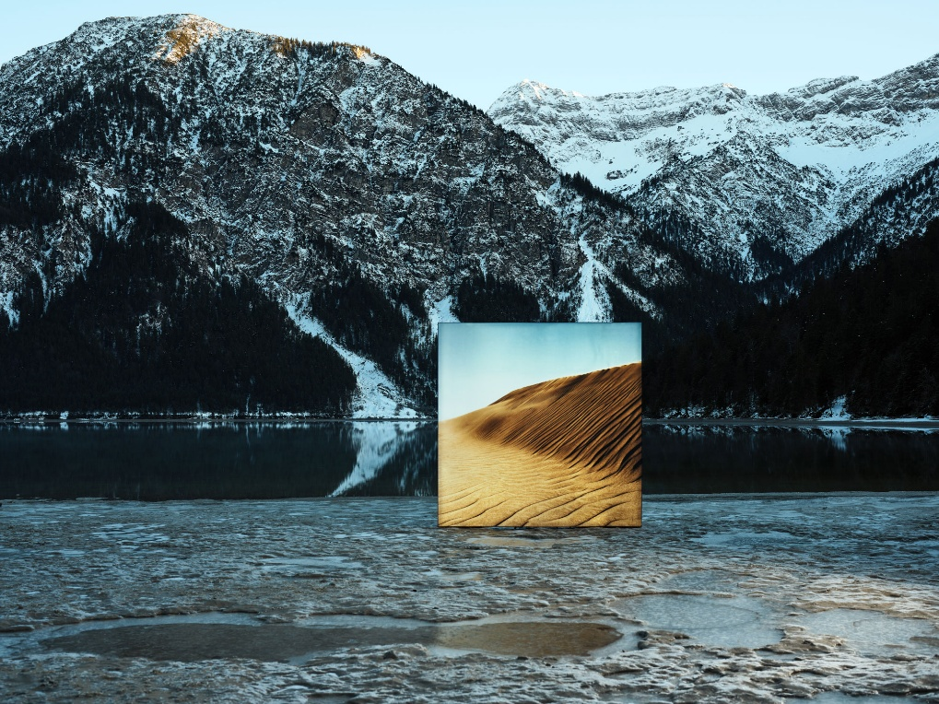
Thought real. Made real.
Rolf chooses not to use AI in its image campaigns.
Not out of principle, but out of conviction. Because authenticity speaks louder than calculated images, perfect surfaces, or artificial smoothness. This image campaign shows people. With edges. With character. With conviction.
This is not a step backwards. It is a conscious decision for authenticity where it should be visible. While efficiency, high-tech solutions, and innovation are fundamental to development and production, this campaign tells a different story: one of commitment, dedication, and real work.
The images are created where things become uncomfortable — outdoors in the Tyrolean Alps. In freezing temperatures, wind, and resistance. The frame is assembled on site, and the different banner motifs are manually mounted. No projection. No studio. Real terrain. Hard work, made visible. No effects, no simulation. Everything real.
Large-scale, manually tensioned banners intervene in the landscape. They create contrast, deliberately disrupt their surroundings, and give the images an unsettling, almost unreal quality. And yet, nothing about them is artificial. Every setup, every motif, every movement happens on site. With time, effort, and attention. Without shortcuts.
This campaign shows what Rolf stands for: progress with purpose. Innovation that supports rather than replaces. Technology where it makes sense — and people where they remain irreplaceable.
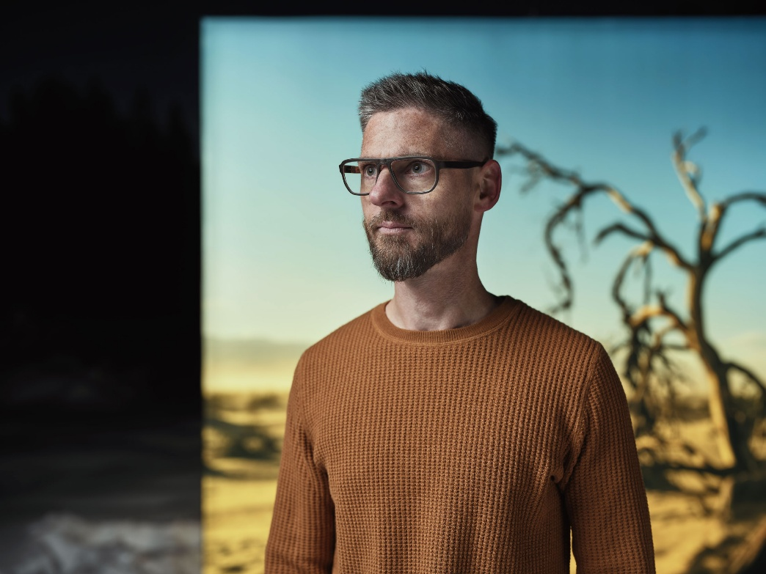
The conscious decision to refrain from artificial intelligence
is not a statement against the future. It is a statement for authenticity.
For work you can feel.
For images that stay because they are real.
#Iamrolf #noAI
__________________________________________________________________________________
About the Rolf Brand
Rolf stands for innovation and spirit. And a deep love of nature. It’s where the raw materials come from – shaped by creative hands into timeless designs. Behind Rolf is a family and a passionate team that creates eyewear with emotion and unconventional methods – eyewear that inspires. With every pair of frames sold, Rolf aims to make a small positive impact on the world and help bring more recognition to values like regionality, transparency, and humanity.
All Rolf glasses are designed, developed, and handcrafted in Weißenbach and are available through select retailers worldwide, as well as in the two flagship stores in Vienna and Reutte.
Rolf. Naturally handmade.

Press contact:  Verena Lechleitner  +43 5678 20077 41  marketing@rolf-spectacles.com | Mühlbachweg 6  6671 Weißenbach  rolf-spectacles.com
  FACEBOOK
  INSTAGRAM
  LINKEDIN
  YOUTUBE

