[Weißenbach am Lech, 20.01.2026]
Images that ensure, because they are real.
Rolf focuses on authenticity rather than simulation in its new image campaign. No generated images, no prompts, no perfection — just real people, real conditions, and real work. Reality in its true form.
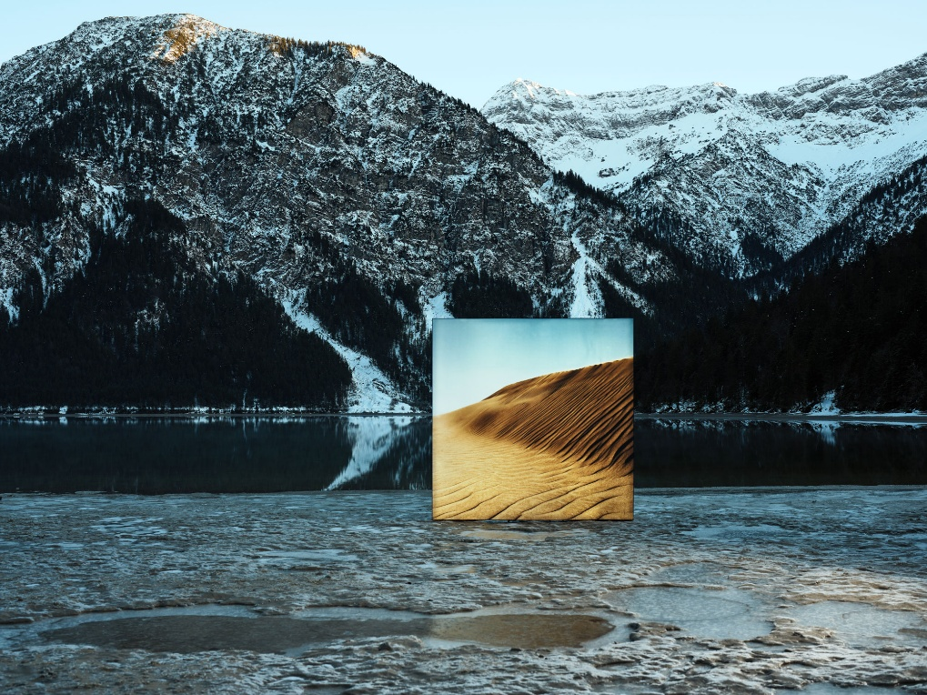
Thought real. Made real.
Rolf elects not to use Artificial Intelligence in the creation of image campaigns
Not out of principle, but out of conviction. Authenticity speaks louder than calculated images, perfect surfaces or artificial smoothness. The campaign shows people for who they really are – full of character, resilience and belief.
While high-tech solutions and innovation are fundamental to development and production, the campaign tells a different story: one of commitment, dedication, and the human touch.
The images were created in atmospheric conditions that only humans can understand — outdoors in the Tyrolean Alps. In freezing temperatures and bracing winds, large backdrops were set up by real people in real locations.
Contrasting landscape imagery disrupts the mountainous surroundings, resulting in an unsettling, almost unreal quality. Yet nothing is artificial. Every scene, every image, every movement takes place in real locations. With time, effort, and attention. No shortcuts.
The campaign conveys what Rolf stands for: progress with purpose. Innovation that supports rather than replaces. Technology where it makes sense — and people where they remain irreplaceable.
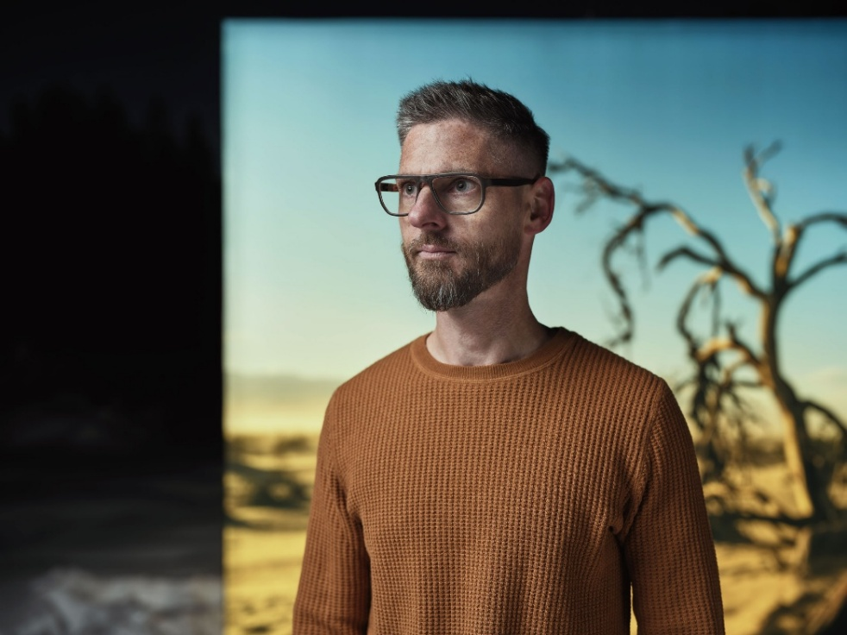

"Our conscious decision to refrain from artificial intelligence in our image campaigns is not one of rebellion against the future, but a statement in authenticity. For images that endure because they are real."
Christian Wolf Co-Founder
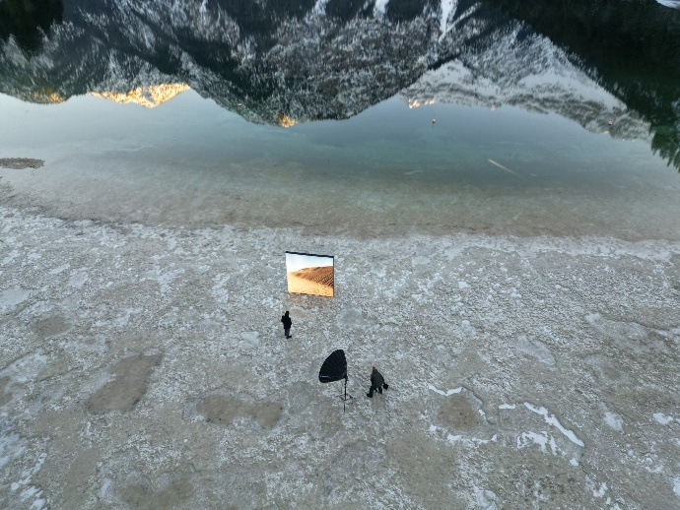 | 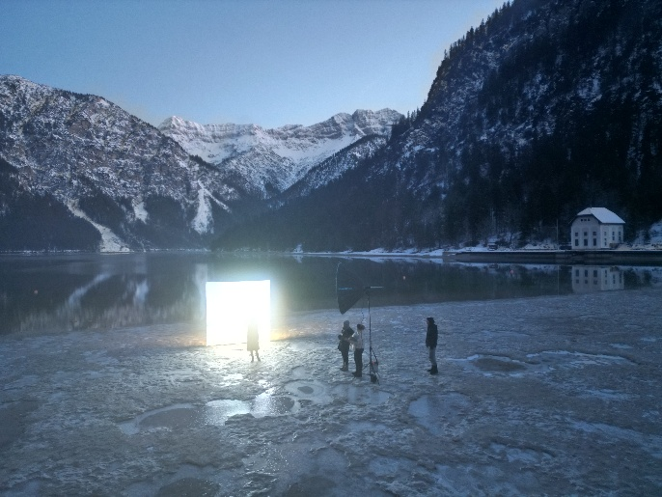
_________________________________________________________________________________
About the Rolf Brand
Rolf stands for innovation and spirit. And a deep love of nature. It’s where the raw materials come from – shaped by creative hands into timeless designs. Behind Rolf is a family and a passionate team that creates eyewear with emotion and unconventional methods – eyewear that inspires. With every pair of frames sold, Rolf aims to make a small positive impact on the world and help bring more recognition to values like regionality, transparency, and humanity.
All Rolf glasses are designed, developed, and handcrafted in Weißenbach and are available through select retailers worldwide, as well as in the two flagship stores in Vienna and Reutte.
Rolf. Naturally handmade.
Press contact:  rolf.  +43 5678 20077  marketing@rolf-spectacles.com | Mühlbachweg 6  6671 Weißenbach  rolf-spectacles.com
  FACEBOOK
  INSTAGRAM
  LINKEDIN
  YOUTUBE

