**Rolf. Eyewear. Novelties SILMO 24**

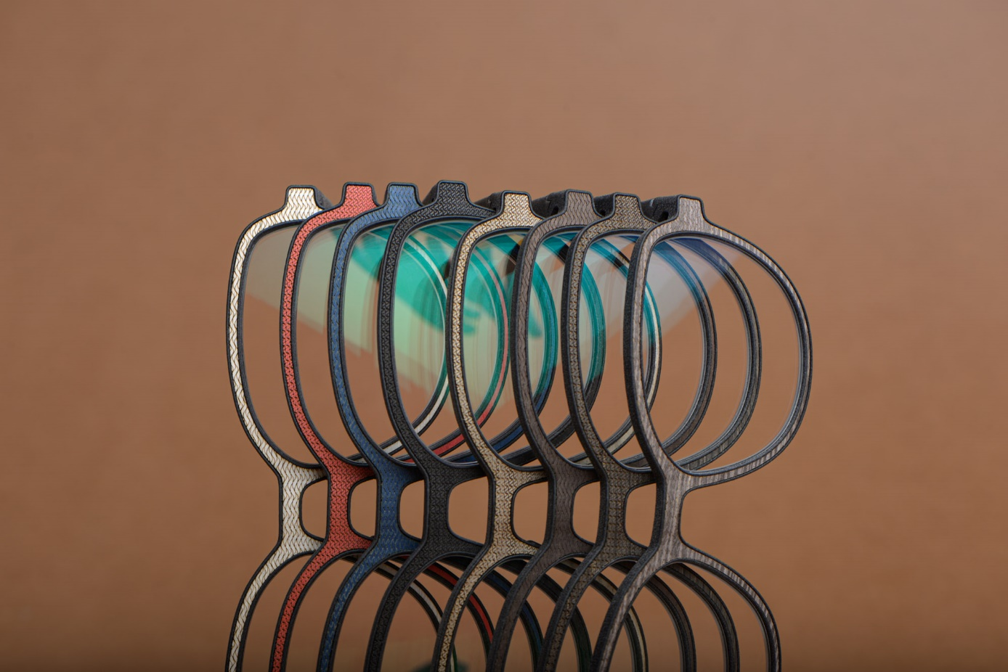

**Silmo Paris is the final trade show of the eyewear season.**  For this event, Rolf unveils thirteen brand-new styles from five distinct eyewear collections. Inspired by the refined elegance and timeless romance of France, the *Classics* models feature eyewear designs that highlight a vintage, sophisticated aesthetic.

**A refreshing twist of eyewear designs from the typically understated and traditional design language of Rolf.** Johannes Wacker, Rolf’s designer, adds an unexpected spin that provides an enticing allure. "About a quarter of our new designs - which we've named *Character* - are bold, vibrant, and extravagant, perfectly matching the fashion capital - Paris. These pieces are for courageous, fashion-forward wearers."

__________________________________________________________________________________

**Big news for little adventurers - perfect for the start of school!** The new Substance kids' eyewear offers stunning, bold, colorful designs for tiny and big explorers. These glasses do not only stand out with impactful color combinations and unique shapes; they are also handcrafted with the children's needs in mind. The thoughtful design ensures that little ones have clear vision, while the silicone pads provide a comfortable fit on little noses. Plus, the patented Flexlock® hinge offers both flexibility and stability, making these glasses ideal for any adventure!

WIRE KIDS

**HARE M**

Ein Bild, das Brille, Zubehör, Spektakel, Schere enthält.

*These nearly square, colorful children's glasses are compact and whimsical with rounded corners - ideal for stylish young explorers.*

FUSION

**LUPIN M+L**

Ein Bild, das Brille, Brillen, transparentes Material, Zubehör enthält.

*Lupin takes your look to a whole new level - discreet as a secret agent and charming as a butterfly on the catwalk.*

EVOLVED

**CHARLSTON 128**

Ein Bild, das Zubehör, Brille, Spektakel, Sonnenbrille enthält.
*Ein Bild, das Brille, Zubehör, Sonnenbrille, Brillen enthält.
*

**Ein Bild, das Menschliches Gesicht, Person, Lächeln, Baum enthält.
**

*CHARLSTON wooden frames captivate with cat-eye curves and an enchanting natural appearance. A harmonious blend of retro charm with contemporary sophistication! Also available in stone.*

*Visit us at Silmo in Paris.*

*Silmo Paris | 20-23 September 2024*

*Hall 7 | Booth D052*